Retirement the Distribution Phase
Food for Thought

Objectives:
- Avoid experiencing Money Death
- To maximize your (or your heir’s) spending dollars

Sources of Income:
- Social Security
- IRA’s
- Roth IRA’s
- Non-Tax Sheltered Accounts
- Pensions?
- Other: Royalties, Business Income, Consulting, etc.

Paycheck Replacement:

How to go about creating a regular stream of income to support your retirement life style.

2023 Tax Brackets
For married individuals filing jointly:
- 10%: Taxable income up to $22,000
- 12%: Taxable income between $20,001 to $89,450
- 22%: Taxable income between $89,451 to $190,750
- 24%: Taxable income between $190,751 to $364,200
- 32%: Taxable income between $364,201 to $462,500
- 35%: Taxable income between $462,501 to $693,750
- 37%: Taxable income over $647,850

For individual single taxpayers:
- 10%: Taxable income up to $11,000
- 12%: Taxable income between $11,001 to $44,725
- 22%: Taxable income between $44,726 to $95,375
- 24%: Taxable income between $95,376 to $182,100
- 32% Taxable income between $182,101 to $231,250
- 35%: Taxable income between $231,251 to $578,125
- 37%: Taxable income over $578,125

The IRS also announced that the standard deduction for 2022 was increased to the following:
- Married couples filing jointly: $27,700
- Single taxpayers and married individuals filing separately: $13,850

Knowing current tax law and a household’s annual spending plan, one can attempt to plan their distributions to minimize tax with a goal of maximizing their net income.

The trick is to look at the whole picture, not just this year or next. If your household is adequately funded and you attempt to minimize taxes annually in the early retirement years, RMD’s could be a tax bomb later is retirement.

Managing your taxable income through the years can also help prevent having to pay increased Medicare premiums. Below are the 2022 income numbers and the Medicare surcharges for medicare part B also known as income related monthly adjusted amount (IRMAA). Similar surcharges are added to your Part D medicare. The income limits are your modified adjusted gross income or MAGI which is usually higher than your adjusted gross income.

Social Security Tax income cap: $160,200

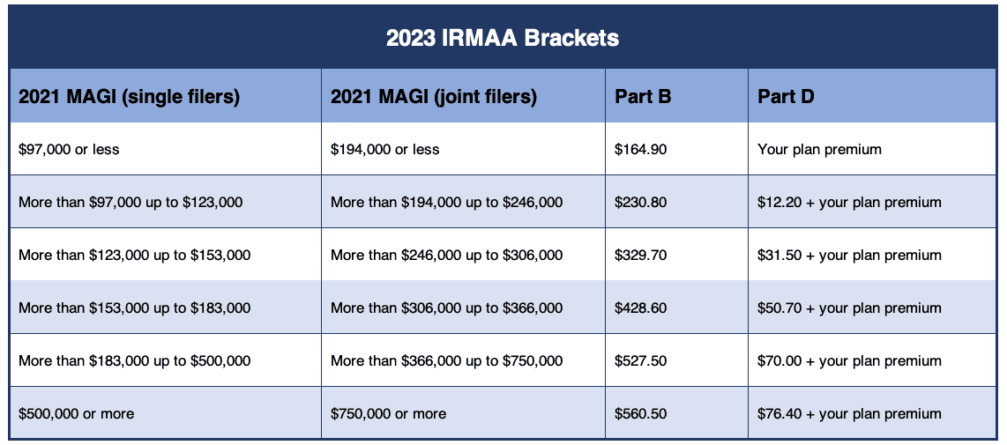

The distribution phase is a chess game in that you should always being looking multiple moves ahead.

REQUIRED MINIMUM DISTRIBUTIONS
AT VARIOUS AGES

73 3.8%
75 4.1%
80 4.95%
85 6.3%
90 8.2%
95 11.2%

